The Mindful Compassion Partnership
Autumn Weekend Retreat

‘Mindful Compassion and Loving Kindness’

Dates: Friday 27th September 2019 registration at 4.30pm with to Sunday 29th, 2019 at 4pm.

Facilitators: David Oldham, Ann Burgoyne & Annette Boden

This weekend we will be exploring how the practice of ‘Loving Kindness’ can help to develop our Mindful Compassion practices, our caring, kindness and giving, to benefit both ourselves and all those we come into contact with in our lives
We will be practicing meditation, reflection and mindful sharing in the group in the supportive environment of Cliff College

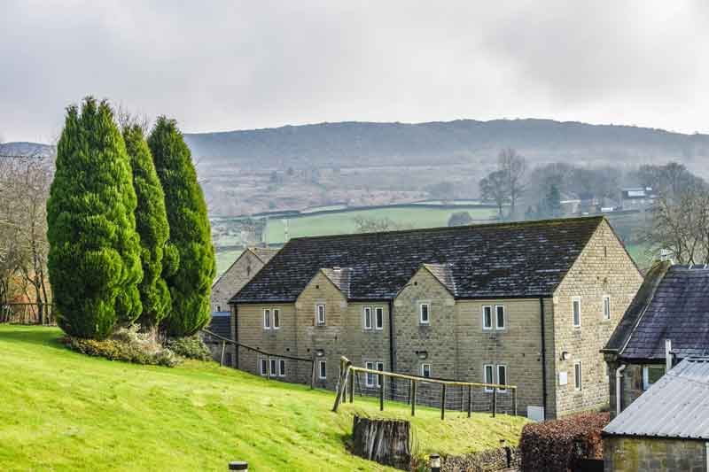

Cost: £230 per person, includes full board and residential en-suite accommodation in a stunning rural setting.
Couples wishing to share a double room will receive a £30 discount.

Venue: Cliff College, Cliff Lane, Calver, Derbyshire, S32 3XG.

Places are limited so don’t hesitate and make your bookings as soon as possible by completing the booking form and following payment instructions. If you require further information please contact: mindfulcompassionpartnership@gmail.com
Or check our web site at; https//themindfulcompassionpartnership.uk

Autumn Weekend Retreat September, 2019 - Booking Form

Name

Address

Postcode

E-mail

Telephone

Do you have any dietary requirements? Yes / No

If yes, please give details:

Payment in full - £230 by BACS or Cheque (Please tick payment option):

- BACS to The Royal Bank of Scotland; Account Number -12642355,
Sort Code 16-32-21 Account Name; D C Oldham Esq (please reference course name)
- Cheque to D C Oldham Esq to 40 Machine Street, Amlwch, Anglesey, LL68
9HA
.
Places are limited and must be paid for when booking a place

Cancellations & Refunds for this event:

If a participant cancels their booking a refund will be offered as follows:
- Cancellation with 16 – 9 weeks inclusive notice – 50% refund
- 4 - 8 weeks – 25% refund
- Less than 4 weeks – no refund.
Where the decision has to be made to cancel an event we will advise everyone booked to attend of the decision as soon as possible and offer a full refund.

Data protection; We work within the guidelines of the GDPR 2018 and have a privacy policy that can be viewed by request, no data we hold is shared with any other party and you may unsubscribe from our mailing list at any time by emailing us.

Signed: Date:

Please return your completed form by email to mindfulcompassionpartnership@gmail.com
or to David Oldham at address shown above for payments.
Thank You!

